PHASE 4: PROJECT PLANNING PHASE

Project Plan
The project is planned in different stages to complete the ServiceNow data import process.

Step 1 – Prepare Spreadsheet
Create a Google Spreadsheet containing sample employee data and download it in .xlsx format.

Step 2 – Create Employee Table
Create the Employee Test custom table and add the required employee fields.

Step 3 – Create Import Set
Create the Employee Import Import Set table and load the spreadsheet data.

Step 4 – Create Transform Map
Create the Sample Spreadsheet Import Transform Map and connect the Employee Import source table with the Employee Test target table.

Step 5 – Transform Data
Run the Transform Map and verify whether the employee records are successfully created.

Step 6 – Enable Coalesce
Configure Coalesce to prevent duplicate records when the same employee data is imported again.

Step 7 – Create Reports
Create reports for department-wise employees, location-wise employees, and employee records.

Step 8 – Create Dashboard
Create the Employee Analytics Dashboard and add the three reports to it.
This planned sequence provides a complete flow from spreadsheet preparation to final data visualization.
Create Transform Map

In this phase we need to create the Transform Map by clicking on the Create Transform Map button as shown in above screenshot.

Give inputs as shown below.
Name: Sample Spreadsheet Import
Source Table: Employee Import is auto-populated
Target Table: Employee Test - as we created earlier
Click on Auto Map Matching fields.

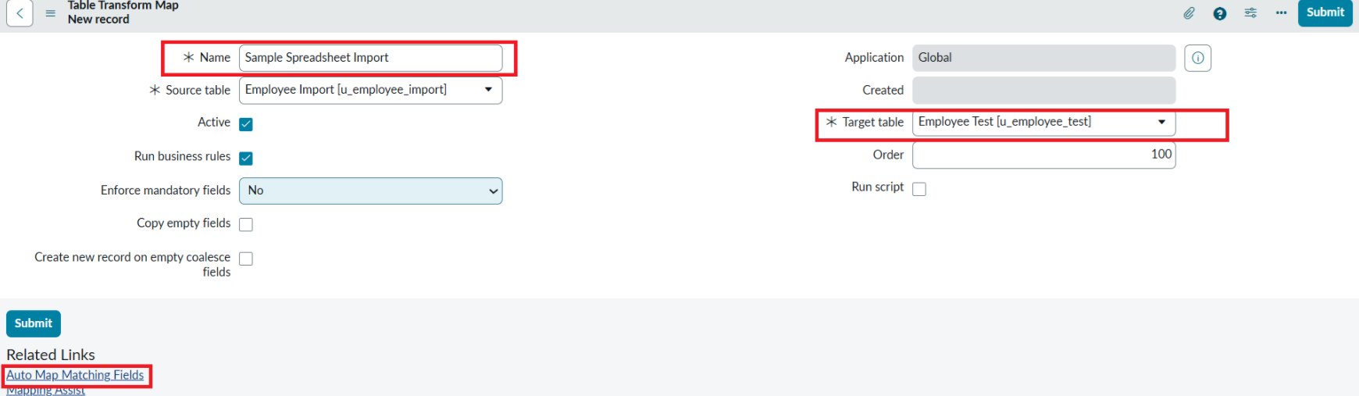

Now click on Mapping Assist and map the fields with Source & Target Table
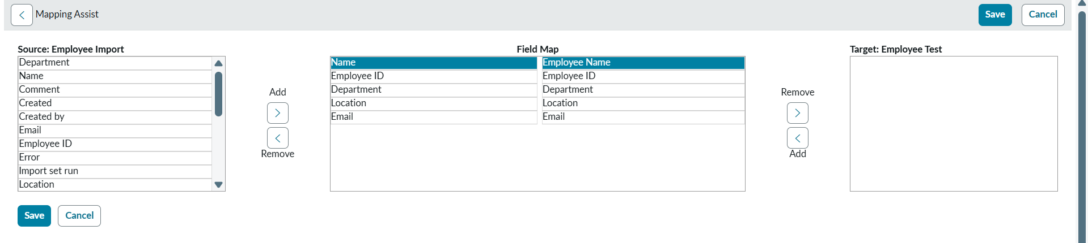
Click on Save
Make sure the both Source & Target table fields are mapped as shown below.
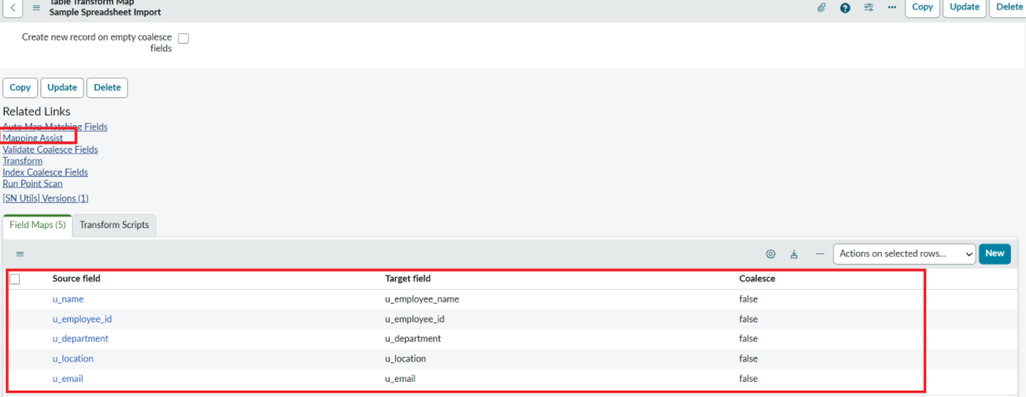

- Now click on Transform as shown below

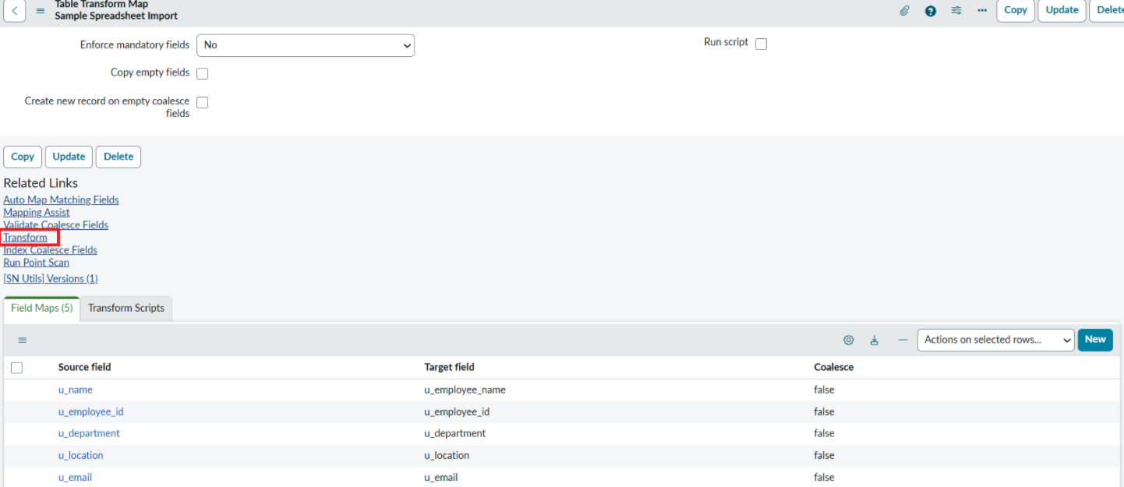

- Now click on Transform Button as shown below.

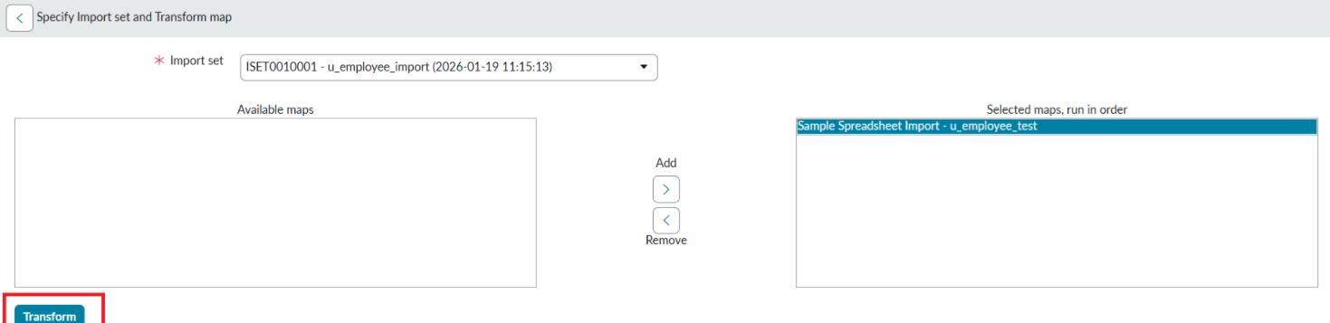

- After clicking Transform, make sure you see the success message as shown below.

